THIS DEED OF TRLifiT execut•d en this 24 day of Apri!, \’ear 2917 BY

N.RAJA (Party of the first part), Son of NARYANASETTY Resident of No.60/1,1” Floor , 2^{n} Cross, Shanimathma Temple Street, Devasandra K. R. Puram, Bangalore-560036 hereinafter called “ SECRETARY OF THE TRUST” (which expression shdll, unless eKcluded by or repungnant to the context, be deemeci to inclucie his executors, administrators and representativesj DUAL EDUCATfONAL & CHARITABLE TRUST

rR!NClPAL PLACE OF TRUST:

The principal office of the Trust shall be situated at Katha No 4758/d871/2448/128, Ground Floor, Next to Texmo !n.dustries, Backside of Ayappa Swamy Temple, MV Extn, Fiosakote dangaiore Rural District-562114. Or such other place as the Trustees may from time to time decide. The Trust may also carry on its work at any other piace or places, as decideci by the

1. No. 5, Above Pritham Studio, Bustand Circle, Kolar Road, Vemgal, Kolar District-563101

2.

4.

7.

TERY

5
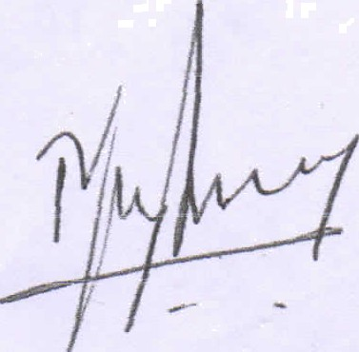

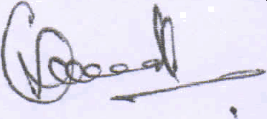

Department of S†omos ond Reg is†ro†ion

1 DD Paid in Cash

look 24/OA/2017

Designed and Develoyad by C DAC .ACTS Pune.

TRUSTEE» OF THE TRUST:

- PRESIDENT-. R NAGAMMA W/O N Raja aged about 35 years residing at No.88/7, Venugopla Swamy Temple Street, Devasandra K. R. Puram, Bangalore-560036

- SECRETERY. N RAJ A S/O Naraynasetty aged about 45 years residing at at No.88/7 , Venugopia Swamy Temple Street , Devasandra K. R. Puram, Bangalore-560036
S.TuES>lJREñ- FlGvvDE OFDA K M S/o Late fv)uniynppa ageé about 42 years residing at h'“ Cross CollaRe Road M V Extention, Hosakote Bangalore Rural District-S62114.
4. DIRECTOR - MANJUNTHA SV S/o Venkataravanappa aged about 43 years residing at Sarkar Guttahalli Village, Dhoddgattiganabbe Post , Hosakote Taluka, Bangalore Rural District Rural-562114
6 DIRECTOR T V JAYANNA 5/0 T.S. Veeranna Gowda aged about 45 years residing at Thirumalahatti, Malur Taluk , Santhehalli Post, Masthi Hoabali. Kolar Distr ict

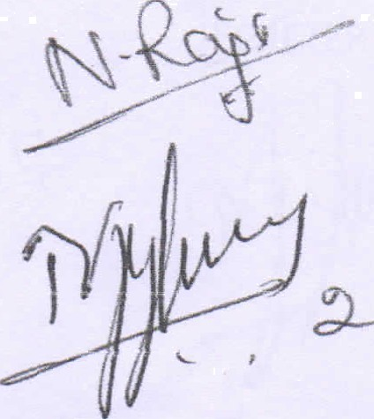
/’= yq ' ,
\

- ” ,
:, . - I.. › L

Print Da†e & Time 24-0d-2017 D4:33: T 5 f°M

sc&3 I?. Nagarnmo W/o. N. I?aja

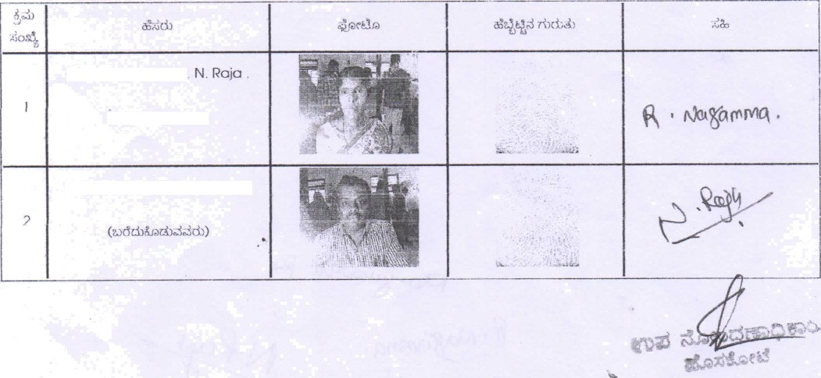
f2. Nagammo W/o
N. Raja S/o. Narayanaset ly

Hereinafter jointly called ’be Trustees" (which expression shall, unle excluded by or repugnant to the context or meaning thereof be deemed to include the trustee or trustees for the time being of these presents and their successors in office and their heirs, executors and administrators of the last surviving trustee, or his assignees) of the other part.
WHEREAS the party hereto of the first part is desirous of creating a Educational & Charitable Trust for the benefit for the humanity large.
ANO WFfEREAS each of the parties hereto of the "Other part" has individually and jointly has agreed to act as Trustees of the Trust , proposed by the party of the first part.
AND WHEREAS nothing contained in this deed shall be deemed to authorize the trustees to do any act which may in any way be construed statutory modification thereof and all activities of the trust shall be carried out with a view to benefit of the public at large, without any profit motive and in accordance with the provision of the Income-Tax Act, 1961 or any statutory modification thereof.
ANO WHEREAS the trust is hereby expressly declared to be a public charitable trust and all the provisions of this deed are to constituted accourdingly.
AND WHEREAS it is necessary to declare the objects and terms of the public charitable trust, being constituted under these presents.

NOWTHIS INDENTURE WITNESSETH AS FOLLOWS:
- TRUST FUND
The party of the first part, the settlor, does hereby settle the sum of Rs 1000/-
(Rupees One Thousand Only ) ( Hereinafter called the "Trust Fund" which expression shall include cash and any other property or investment of any kind whatsoever into which the same or any part thereof might be converted, invested or varied from time to time or which may be acquired by the trustees or may come to their hands by virtue of these presents or by operation of law or otherwise howsoever in relation to these presents) in Trust, with the name and for the objects hereinafter stated, by delivering the said amount in cash which the party of the other part, the Trustee, have accepted the receipt of which they do hereby acknowledge, to hold the same in and to the Trustees with the powers and obligations as provided hereinaker. "

S ETERY

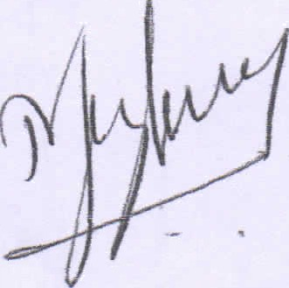

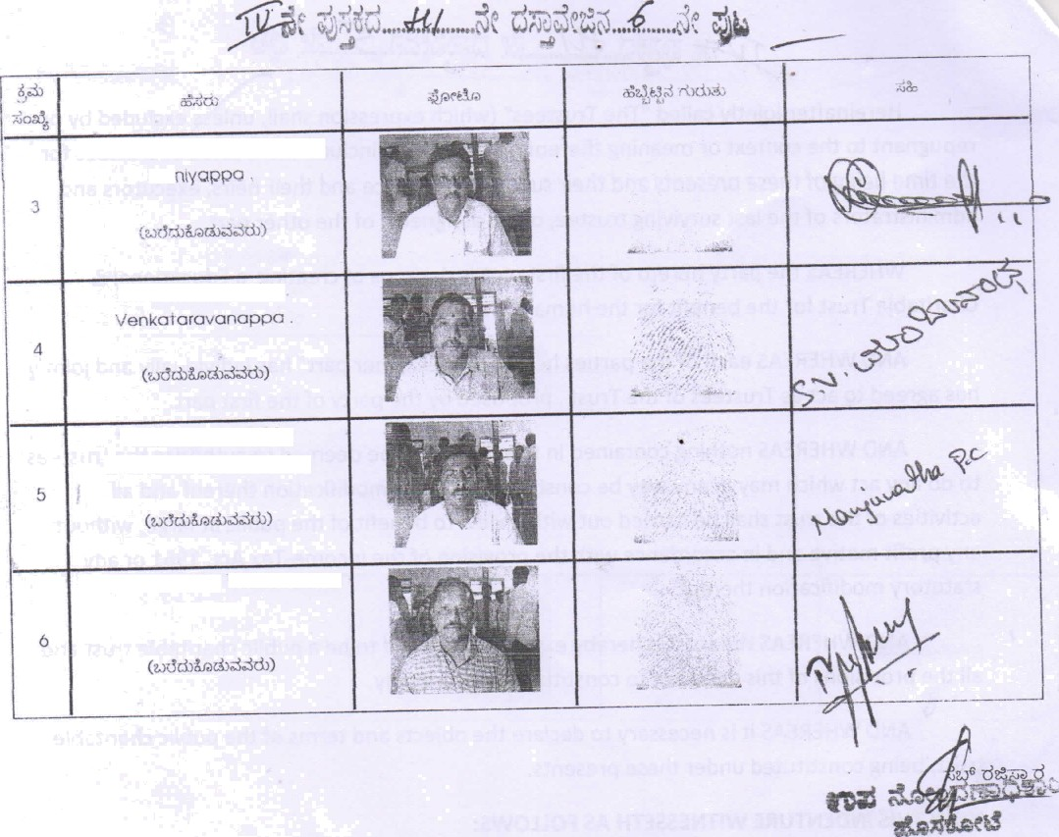
ChowdegowdCyK.M S/o. Late
Mu
Manjunatha S V S/O
M on jur \oth O.P.Z 5/O.
Chikkanarayana She1ty .
].V. JO Of\CIO /O f. . \/eOfOnFtO

- NAME

The name of the Trust shall be" UJWAL EDUCTIONAL & CHARITABLE TRUST“.

- PLACE:

The principal office of the Trust shall be situated at Katha No 4758/8871/2448/128, Ground Floor, Next to Texmo Industries, Backside of Ayappa Swamy Temple, MV Extn, Hosakote Bangalore Rural District-562114 or such other place as the Trustees may from time to time decide. The Trust may also carry on its work at any other place or places, as decided by the Trustees.
é' OBJECTS:

- To establish, run, maintain, assist or grant aid or other financial assistance to schools, colleges, Training Institutions, libraries, laboratories, educational, Hospitals, Hostels and Old Age Homes for disables or other institution of the like in India, for use of the student and staff and also for the development, advancement of education and diffusion of knowledge amongst the public in general

- To establish, run, maintain, assist or grant aid or other financial assistance to school, colleges, libraries, laboratories, educational or other institution of the like in India, for coaching, guidance, consoling or vocational training or to grant individual schola,rships for poor, deserving and needy students for elementary and higher education.

- To give financial or other assistance in kind by way of studentships, scholarship, stipends, medals, distribution of book, notebooks, «loths, uniform, or meals for the poor Students of Government Schoels and te tbe persons suffer due to nature calamities at free of cost.

- To give Financial or other Assistance in kind to Blind Peoples, Physically Handicap People, Poor People and Old Age Persons and Old Age Homes. Financial or Other Assistance in Kind to Poor People for Medical Emergencies like Accidents, Major Operations and others

- Other objects of general public utility -
to acquire property for the sole use for public goob by making it available for public purposes as for example, housing a library clinic, crech and/or as a community hall to be available for public use as training classes, seminars, discourses and other public functions for benefit of the community in general.
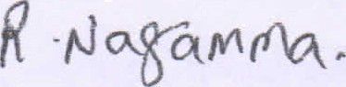
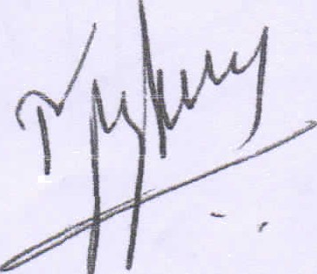

ETERY

Devaiaj S/o. Krishnappa
Got1ipura Village. Hoskote Taluk
2 | Madhukumar S/o. Muniyappa  Doddanalluru Vlllage. Hoskote taluk

UJWAL EDUCATIONAL & CHAf?ITABLE TIUST

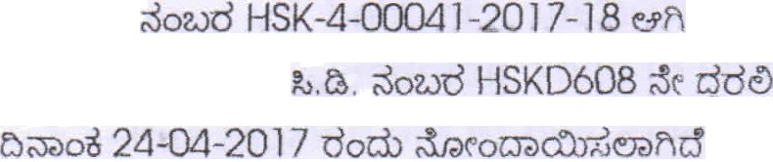

Dcslgned and Developed by C-OAC. ACTS. Pune

- to undertake any other activity incidental to the above activities but which are not inconstistent with the above object.
PROVIDEO the Trust may assist/donate to any other TRUST to carry out the various objects mentioned in the objects clause in such manner and to the extent the Trustees may decide upon from time to time.
The Trust has been created for charitable and religious purpose within the meaning of the income Tax Act, 1961 and object of the Trust are to afford relief for the poor, advancement and encouragement of Indian culture, Literature and Educational activities. The objects of the Trust will not include objeNs involving the carrying on of any activity for profit within the meaning of the Income Tax Act, 1961.
BOARD OF TRUSTEES
The Trust shall be managed by Board of Trustees consisting of not less than three and not more than from Two Categories
  - Heriditery Trustees and Founder Trustees: Five
  - Co-Opted Trustees for the period of Five years: Five FOUNDER TRUSTEES & HERIDITY TRUSTEES
    - The Authors of the Trust and any person who contributes Rs. 1 lac shall be called an Herederatary Trustees and upon their death or disability the legal heir on
nominated person on the family shall hold office in the place of retiring trustee.
    - The Term of such co-opted trustees shall be period of Five years or he/she volunterily resign or declared as insolvent, insane, suffers from incapacity or death As & when vacancies occur the same can be filled in by co-option.
    - Any Vacancy Caused due to arisin8 out of death, insanity, retirement, abandonment,or sentenced in court of law for moral turpitude, then the co-opted trustee sñall Automatically lose his trusteeship and in his place the Board of Trustees shall elect an individual trustee depending upon the category to which trustee concern belongs

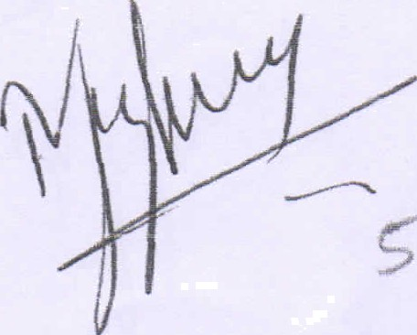

CRETERY

BENEFICIARIES OF THE TRUST :
Provided that the application of the Trust funds and assests shall be done without description of nationality, religion, caste or creed
- FUNDS

The Trustees may accept donation, grants, subscriptions, aids or contributions from any person, Governments, Local authorities or any other charitable institutions, in cash or in kind including immovable property without any incumbrance, but the Trustees shall not accept any receipt with any condition or terms inconsistent with the object of the Trust. While applying such receipt to the objects, the Trustees shall respect the directions, if any, by the granter. Any receipt with specific direction to treat the same as part of the corpus of the Trust or separate fund shall be funded accordingly.
- INVESTMENTS :
i. All monies, which are not immediately required for current needs shall be invested by the Trustees in eligible securities and investments, or in banks. Such investments shall
be in the name of Trust or Trustees.
That the trustees shall manage the trust fund and investments thereof as a prudent man would do the same. They shall recover all outstandings and meet all recurring and other expenses incurred in the upkeep or management thereof.

iii. That the trustees shall receive and hold the income of the trust on behalf and for the benefits of the beneficiaries under the trust.

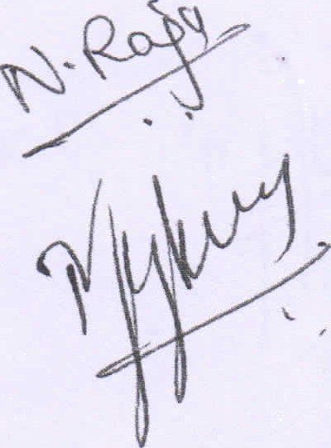

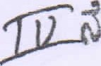

7.POWEROFTHETRUSTEES:
That the trustees shall have the following powers :

i.

ii

iii.
iv.
V.

VIII.

iX.

x.

xi.
xii.
to manage all the assets and/or properties of the trust
to appoint employees and to settle the terms of their service, remunaration and
termination;
to look into the management of the trust;
to invest the funds of the terust, in bank or other movable and immovable properties; to sell, alter, very, transpose or otherwise dispose or a(ienate the trust properties or any investments representing the same for consideration and to operate the same;
to pledge or mortgage the trust properties for raising loans;
to open the bank accounts in the same and on behalf of the trust and to operate the same;
To pay all charges, impositions and other outgoings payable in respect of the trust properties and also to pay all cost of the incidental to the administration and management of the trust properties.
To file suit on behalf of the trust and to after to arbiration all actions proceedings and disputes touching the trust properties and to compromise and compound the suits field; To accept any gift, donation or contribution in cash or in kind from anyone for the objects of the trust;
To seek legal opinion of lawyers and/or Chartered Accountants as and when required; To nominate their representatives for any of the aforesaid purpose,

  - The number of the trustees shall not be less than two but not more than ten. If the number of trustees shall fall below two, the remaining Trustee shall not, expect for the purpose of filling vacancy, act so long as the number is below the said minimum.

CRETRY

yy‹ O_«///..¿\t dñ=g *.¥.1..J.,T,¿t gU

  - A person shall cease to be a Trustee either (i) if he, without leave of absence, does not attend to three successive meeting of the Trustees or for one calender year, whichever is longer, or (ii) if he is requested to resign by 3/4* or so near thereto as possible of the remaining trustees.

is.

16.

17.

18.
The trustee will not entitled to receive any remunaration in any form for the service rendered. However, the expenditure actually incurred by them in connection with the trust or their duties relating thereto may be reimbursed.
In case of any difference between the trustees, the opinion of the majority shall prevail. Every trustee will be at liberty to nominate or oppoint attorneys or agents and to delegate all or any of the duties and powers vested in him to such attorney or agent, and to remove such attorney or agent and reappoint other or other in his place.
No trustee shall be responsible or liable for any loss or any act of omission or commission by his constituted attorney or agent or employees or other trustees unless occasioned by his wilful neglect or default.
Any of the trustees may retires on giving one menths notice in writing to the other trustees.
If any trustee dies or retires or becomes incapable or unfit to act, the continuing o,r surviving trustees shall appoint a successor in the place of the such trustee.
At any time the existing trustee{s) shall have the power to appoint new trustee(s) for the furtherance of the objectives and subject clause 8 supra.
Upon the appointment of a new trustee the trust properties shall vest in the new trustee jointly with the continuing or surviving trustees, with the duties and powers of the trustees set out hereinabove in this need
The Trustees may from time to time frame rules for the conduct and regulations of the meetings of trustees. In the absence of such regulations;
- At least two meeting of the Trustees shall be conducted in a year.
- Three Trustees shall from a quorum for a meeting of the Trustees
- All the matter relating to Trust activities shall Be mutually decided by the Trustees
- Resolution passed and decisions taken at such meeting shall be communicated to all the Trustees and shall be binding on the Trustees.

5

POWER AND DUTIES OF INDIVIDUAL OFFKE BERERES

PRESIDENT:
18 A (i) The President shall have power:

  - To Preside over all meetings of the Board of Trustees of the office Bearers of the Trust
  - To Call for the meetings of the Board of Trustees or the office bearers in special circumstances .
  - To have supervision and control over Trust Funds.
  - To Exercise Casting vote in case of tie in any matter in the meetings of Board of Trustees or Office Bearers.
  - To make needful decision along with other office bearers in time of emergency and promotion of the objects of the Trust.
- To address letters to the dignataries on important matters
- To Mobilise Funds for the Trust.

18.B THE SECRETERY The Secretery Shall:

- be the executive officer of the of the Trust
- Accept all notices summons and Trusts.
- Sue or be sued for and behalf of the Trust . unless otherwise decided.
- Function as per the directions of the Board Trustees, office bearers of the Trust and President of Trust in the order
- Operate the Bank Account Singaly
- Provide the relavent Papers with the notices of the president to any Trustee.
- Maintain the Minutes of the proceedings of Board of Trustees or the office bearers.
- Prepare the Agenda for the meetings of the Board of trustees office Bearers
jjLook after all the correspondence of the Trust.
- Implement all the resolutions of the Beard of Trustees and effice Bearers Trust in the Order.
  - Implement all the Resolutions of the Boards of Trustees and officer bearers of the trust of the Order
J) To convey the meetings of the Board of Trustees office Bearers or sub committee

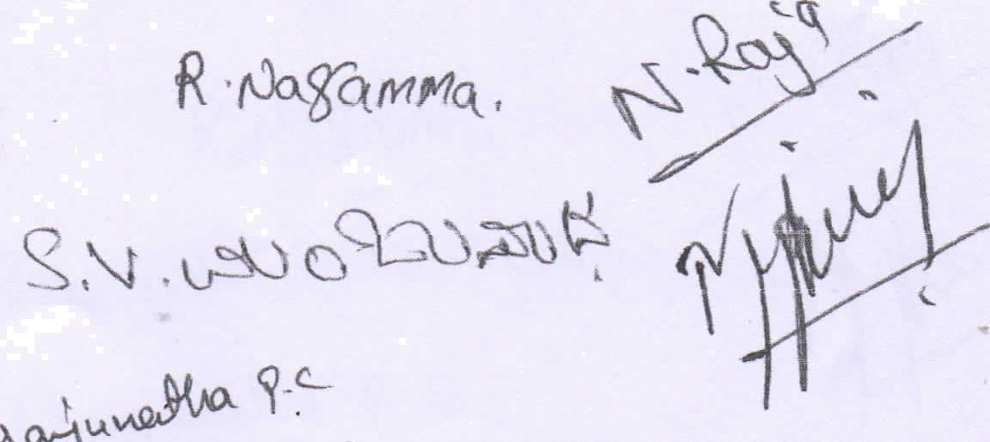

18 C The Treasurer The Treasurer shall
- Maintain or cause to be maintained all books of accounts as per the directions of the Board of Trustees and
- Prepare the or cause to be prepared statement of receipts and payments incurred for every month and place the same before the office bearers of the Trust with the co-oridinatie and assistance of the Secaretery.
- Maintain or cause to be maintain all necessary books of Accounts Vouchers and other concerned documents in the office of the Trut.
- Submit or cause to submitted his accounts to the internal Auditor for the Annual Audit
and prepare for or cause to be prepared for Annual Statements of Accounts including receipts and payments , Income and expenditure and Balnce sheet and place the same for approval of office Bearers of the Trust and after approval circulate the same among all the trustees.
- Mobalise the funds for the Trust.

BANKING ACCOUNT:
All income, subscription and pecuniary donations for the general purposes of the Trust And the income, investments and all other moneys from time to time forming part of the general revenue of the Trust shall on the same being received be paid into a banking account with any scheduled bank for the purpose of the Trust. The bank
accou
be operated by the Secretory only .

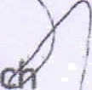ACCOUNTS AND AUDIT
- The accounting year of the Trust shall be the financial year ending on 31* of Mar every Year.
- The Trustees shall keep proper books of the account of all the assets, laibilities and income and expenditure of the Trust and shall prepare an Income and Expeniture Account and Balance Sheet for every year as on the last day of March.
The accounts of every year shall be audited by a Chartered Accountant or a firm of Chartered Accountants who shall be appointed for that purpose by the Trustees and the audited accounts shall be placed at a meeting for the Trustees, which shall be held before the end of the succeeding year.
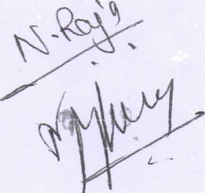

11. IRREVOCABLE

This Trust is irrevocable.

- AMENDMENY

Any amendment to this document shal be affected in respect of the provisions applicable to the Trustees and other matters. Provided no alterations or amendments shall be carried out without the proper prior approval of Commissioner of Income Tax.
- DISSOLUTION

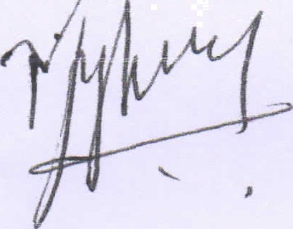
In the event of dissolution or wedding up of the Trust, the assets remaining as on the date of the dissolution shall under no circumstances be distributed among the Trustees. But the same shall be transferred to another charitable trust, society, association or institution whose objects and faith are similar to those of the Trust and which is registered under section 12A of the Income Tax Act 1961.
ERY

At present the Trusthas no property or assets, either movable or immovable. Other than the Trust fund donated by the SETTLOR, as described in the schedule below:
1. Cash contribution to the Corpus Fund of the Trust of Rs. .... ............/- (Rupees........................

IN WITNESS WHEREOF THE SETTLOR AND THE FIRST TRUSTEES here to have set their hands on the day, month and year first above written.

SIGNA
E
RETERY
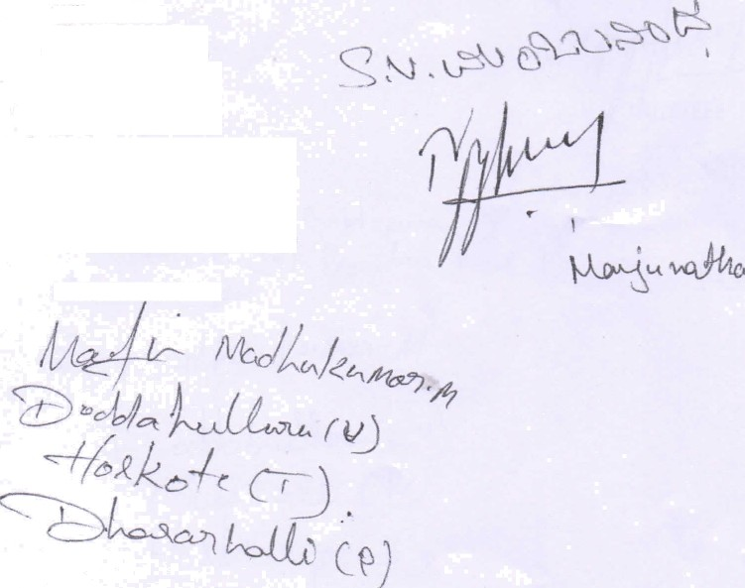
Witnesses :
. Signature Nam ddress
’“'”I° * 'pu•° i«
US
gntures
Name & Address

The Trustees shall be indemnified against all losses and liabilities incurred by them in the execution of the Trust and shall have a lien over the funds ansd properties of the Trust for such indemnity.
IN WITNESS WHEREOF, The Parties hereinto have signed and delivered the presents of the dav and year first herein above written.

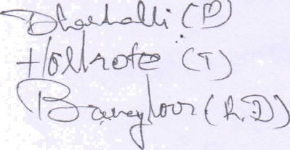
(2)
USTEES
WITNESS

